Creating Kaleidoscopes

Subject: Physics  Related Subjects: Optics, | Grade Level(s):  Length of Lesson: | Type: Inquiry / Design / Project  Keywords: Reflections, Light Polarization, Wave

Lesson Overview
Students will use kaleidoscopes to learn the fundamentals of optics, as well as explore light, similar to how this would be done with a prism. Moreover, students will learn basic terminology for naming light waves and wave interactions.

Lesson Focus
Students will explore the phenomenon responsible for making light behave the way it does in real life through the creation of a kaleidoscope, just as physicists did in the early 19th century.

Lesson Objective(s) | The student will learn about the fundamentals of optics

Lesson Timing

Time [min] | Description
5 | Introduce the Lesson  - End Goal  - Primer Questions  - Key Vocab Words
1 | Role Models in STEM
Engineering Method
5 | Real World Example
5 | Hypothesis & Prediction
5 | Brainstorm & Design
30 | Build & Create
15 | Test & Record
7 | Assess & Evaluate
5 | How to improve?
10 | Lesson Cleanup

Materials | - 8 Paper Towel Rolls  - 12 Rulers  - 2000 Multicolor Translucent Beads  - 8 Rolls of Clear Tape  - 12 Elmer’s White Glue Bottles  - 10 Hot Glue Guns  - 1 Laminating Sheets pack  - 1 File Folders Pack  - 12 Markers  - 12 Scissors  - 2 Aluminum Foil Packs
Instructor Prep | - Step 1
Related Resources | - https://www.wikihow.com/Make-a-Kaleidoscope  - https://babbledabbledo.com/mini-diy-kaleidoscopes-open-ended/

Lesson Plan

Introduction
- What are applications of light?
  - Lighting
  - Lasers
  - *Variety of other answers
- What are some things we know about light?
  - They warm things up
  - It’s a form of energy.

Procedure
- Allow students to trace bottom of paper towel rolls on laminating sheet using markers. Students may share sheets as they will only cut a small circle.
- Glue cutout laminating sheet to end of towel roll
- Drop hot glue down the tube so that the sealed end of the tube catches glue
- Drop beads down the tube.
- Repeat step 1 for other end of paper roll
- Allow students to measure length of paper tube roll and record this measurement down.
- Students will use the measurement in step 4 to cut 3 cardboard strips of 1 inch width
- Tape the cardboard strips together to form a triangle.
- Place cardboard triangle into paper roll
- Seal end of tube and the kaleidoscope is done

Wrap-up
The purpose of the survey is to let us know your opinions about today’s project. Remember there are no right or wrong answers.

 |  | Strongly Disagree | Disagree | Undecided | Agree | Strongly Agree
1 | The project increased my interest in science
2 | After this project, I am more confident in doing science

3. What does a physicist do?

4. Name two uses of light in the real world.

5. How is light affected by the bead color chosen? Was there anything else you observed?

Lesson Background for Teachers

Suggested Real-World STEM Connections
Yayoi Kusama
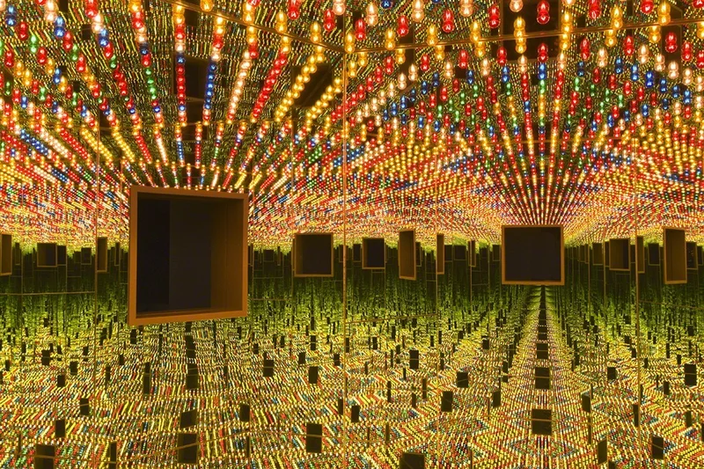

Born in 1929 in Matsumoto, Japan, Kusama’s work has been featured widely in both solo and group exhibitions. She presented her first solo show in Japan in 1952. In the mid-1960s, she lived in New York where she became an important avant-garde artist by staging groundbreaking and influential happenings, events, and exhibitions. In 1965 Kusama produced her first Infinity Mirror Room. Building on the repetition found in her paintings and sculptures, this artwork used mirrors to create an illusion of infinite space. Since then Kusama has made more than 20 unique rooms.

Real World Example
- Lasers
- Ovens
- GPS and Navigation
- Solar Panels

Hypothesis & Prediction
- Students will predict the behavior of light when different mediums are placing between the observer and the opening of the cone

Brainstorm & Design
- Students will attempt to design a unique pattern based off what they know of light
- Students will use the above materials to develop a kaleidoscope
- How will they overcome those constraints?

Build & Create
- As above, students will use all of the materials above with a bit of general guidance in order to create their own kaleidoscopes.

Test & Record
- Students will view through their own created kaleidoscopes and record observations

Assess & Evaluate
- Students will make detailed observations as well as recognize the changes that different colors make to the kaleidoscope patterns.

How to Improve?
- Ask the students what they would improve or change if they were to do it again

Role Model in STEM

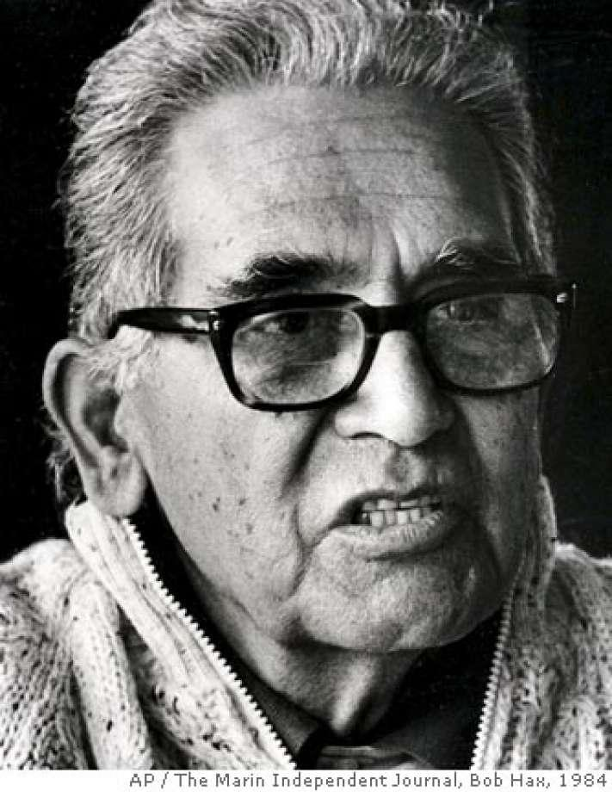
Name: Albert Baez
Years: 1912-2007
Quick Facts
- Invented X-Ray Electron Microscope
- Earned a doctorate in Physics
- Earned Dennis Gabor Award in 1991

Lesson Variations and Options
Different numbers and shapes of mirror alignment can be tried to observe the variation and complexity in patterns created by the mirror and the complex mirror orientation in the tube.

Explanation
When three mirrors of the same size are arranged into an equilateral triangle, rays of light will reflect to form multiple images of any object placed between the mirrors. This is how a kaleidoscope works. The patterns you see through a kaleidoscope are made by light bouncing between the mirrors. When you look through one end of a kaleidoscope, light enters the other end and reflects images of various objects off the mirrors, creating amazing patterns.

Light: Light is a wave, similar to the waves in the ocean. The difference is that light waves are very small. Light waves are all around us, and they interact with every object they encounter. It is light waves that create our perception of colors. To see color, you have to have light. When light shines on an object some colors bounce off the object and others are absorbed by it. Our eyes only see the colors that are bounced off or reflected.
The sun’s rays, and our overhead lights, contain all the colors of the rainbow mixed together. This mixture is known as white light. When white light strikes a white object, it appears white to us because it absorbs no color and reflects all color equally. A black object absorbs all colors equally and reflects none, so it looks black to us. While artists consider black a color, scientists do not because black is the absence of all color.

Mirrors/reflection: A mirror is a shiny surface that can reflect light so well that it preserves any image placed in front of it. This is because a mirror is very smooth, so light reflects off of it evenly. If there is any roughness to a surface, that roughness will cause light to scatter, which distorts an image. What you are actually seeing, when you look in a mirror, is light reflecting off of you! In the daytime, or under artificial lights, light reflects off your body in all directions. That's why you can see yourself and other people can see you. Your skin and the clothes you're wearing reflect light in a diffuse way: light rays bounce off randomly, haphazardly, in no particular direction. Stand in front of a mirror and some of this light from your body will stream in straight lines toward it. This light is reflected directly back off the smooth mirror, and you see your image.

Key Concepts and Vocabulary
- Electromagnetic Radiation
  - A wave of energy where electric and magnetic fields vary at the same time. Light is a form of electromagnetic radiation
- Color
  - A specific wavelength or frequency of light that our brains then perceive as a specific color
- Frequency
  - The number of times a wave of light completes an entire cycle, usually per second (hz).
- Wavelength
  - The length between each successive cycle of a wave
- Prism
  - A tool used to split light into each of its color parts that works through refraction of different wavelengths of light
  - A color
- Visible Spectrum
  - The range of light that we can see

Safety Notes
- Students should use caution with sharp tools

